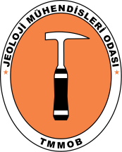 | Uluslararası Katılımlı 72. Türkiye Jeoloji Kurultayı  72nd Geological Congress of Turkey with international participation | 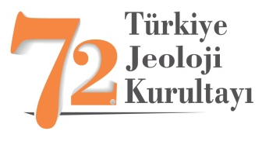

Abstract Title (Times New Roman, First Letter of the Words Capitalized, 12 pt, Centered, Bold)

Author Name Surname¹, Name Surname ², (Times New Roman, 11 pt, centered, bold)
¹Adress1 (Times Roman 10 pt, centered, italic)
²Adress2 (Times Roman 10 pt, centered, italic)
(Corresponding autor e-mail, Times Roman 10 pt, centered, italic)

Abstract (Times New Roman, 11 pt, bold, justify text): Participants must prepare an abstract for the Geological Congress of Turkey, in the style, layout and format in accordance with guidelines outlined here and in the conference website. As it is easier, it is highly recommended to use this page to prepare an abstracts.

The abstract not exceeding 450 words should be informative (aim of the study and main conclusive remarks) and also original. The abstract should be given in both Turkish and English. If the paper is written in Turkish, an English abstract should follow the Turkish abstract, while a Turkish abstract (in italics) should appear after the English abstract in papers written in English. For non-Turkish participants Organizing Committee will provide a help to translate abstracts to Turkish. Citations, reference list, figure, table, special symbol, header and footer should be avoided. All authors are requested to avoid statements, which may cause potential conflict of interest with other people or organizations. The submission of an abstract carries with it the obligation that it will actually be presented at the conference by the author or, at least, by one of the co-authors. The conveners reserve the right to accept or refuse contributions on the basis of the abstracts, if they do not meet guidelines outlined in this instruction. Each participant may submit up two abstracts in which they appear as presenting author.

Keywords: Word 1, Word 2, … The abstract should include minimum 2, and not more than 7 key words that the authors would like to see in the index page. Key words should be given in both Turkish and English. Key words should be written in lower-case letters, separated by commas, and given in alphabetical order.

